UDST Smart Parking Management System – Design Document

1. System Overview
The UDST Smart Parking Management System is a web-based platform designed to improve parking availability, reduce search time, and enhance the overall parking experience for students, staff, administrators, and guests on the UDST campus. The system allows users to log in using university SSO credentials, view real-time available parking spaces based on reservation records, and make reservations with a temporary 5-minute lock to prevent conflicts. Users can check in within a 15-minute grace period, check out upon departure, cancel their own reservations up to 30 minutes before the start time, and submit feedback, reports, or complaints. Administrators have additional privileges, including creating guest reservations for events, modifying or canceling any reservation, monitoring parking usage through a dashboard displaying key metrics such as occupancy rate and active reservations, and exporting reports in PDF format. The system also sends reminder notifications 30 minutes before reservation start times and automatically releases expired or unclaimed reservations within 15 minutes. The scope is limited to online reservation management and does not include payment processing, hardware integration such as sensors or gates, mobile applications, or advanced surveillance features.

2. Architectural Design

2.1 Architectural Style
The system follows a Layered Architecture, organized into three distinct layers:
- Presentation Layer: The User Interaction subsystem contains all components that interact with the user: Authentication, User Interface, Notification, Feedback, and Admin Dashboard.
- Business Logic Layer: The Parking Operations subsystem contains the core logic of the application: Parking & Booking Manager, Availability Manager, Parking Management, and Check-In/Check-Out. This layer also communicates with the External Email Service for sending notifications.
- Data Layer: The Database subsystem is responsible for the storage of all system data, including users, reservations, and parking records.

Layered Architecture was selected for this system for the following reasons:
- Separation of concerns: Each layer has a single responsibility. The presentation layer handles user interaction, the business logic layer handles processing, and the data layer handles storage. This makes the system easier to understand and maintain.
- Modularity: Each layer can be developed, tested, and modified independently. For example, the database can be changed without affecting the user interface.
- Reusability: Business logic components such as the Parking & Booking Manager and Availability Manager can be reused across different parts of the system. For example, both the User Interface and the Admin Dashboard access the same reservation logic through the IReservationService interface, without duplicating any code.
- Low coupling: Layers only communicate with the layer directly below them through interfaces, reducing dependencies between components.
- Suitable for the system scope: The parking reservation system has clear and distinct responsibilities across user interaction, reservation processing, and data management, which map naturally onto a three layer structure.
- Ease of maintenance: If a bug occurs or a feature needs to be updated, developers can find the issue within a specific layer without needing to understand the entire system.

2.2 Component Diagram
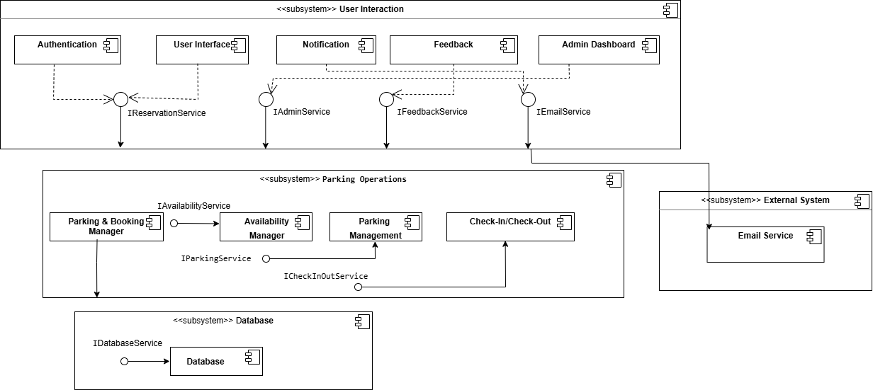

2. 2. 1. Component Descriptions

Authentication: Handles user login, registration, and session management.
User Interface: Provides the main interface through which users interact with the system.
Notification: Sends email notifications for reservation confirmations, reminders, and cancellations.
Feedback: Allows users to submit feedback about their parking experience.
Admin Dashboard: Enables administrators to monitor and manage the system.
Parking & Booking Manager: Manages the creation, updating, and cancellation of parking reservations.
Availability Manager: Tracks and updates the real time availability status of parking spots.
Parking Management: Handles the physical configuration and management of parking zones and spots.
Check-In / Check-Out: Manages the entry and exit process of vehicles at the parking facility.
Email Service: Represents the external email service provider responsible for delivering notifications.
Database: The data layer that stores all system data including users, reservations, and parking records.

3. Class Diagram (Detailed Design)
The class diagram includes 11 main classes: User (abstract), Student, Staff, Administrator, Guest, Parking Space, ParkingZone, Reservation, Notification, Feedback, and Dashboard. For abstraction, the User class is abstract and hides common attributes like name, email, and role, while subclasses add their own specifics. For encapsulation, all attributes are private (-) and public (+) methods are provided to access them. For low coupling, classes use direct object references (e.g., - parkingSpace: ParkingSpace) instead of IDs, so changes to one class have minimal impact on others. For high cohesion, each class has a single clear responsibility: Reservation handles reservations, Notification handles notifications, and Feedback handles feedback. The main relationships include inheritance (Student, Staff, Administrator inherit from User), (ParkingZone contains multiple ParkingSpace objects), association (User makes Reservation, and Reservation occupies ParkingSpace), and dependency (Reservation depends on ReservationStatus enum).
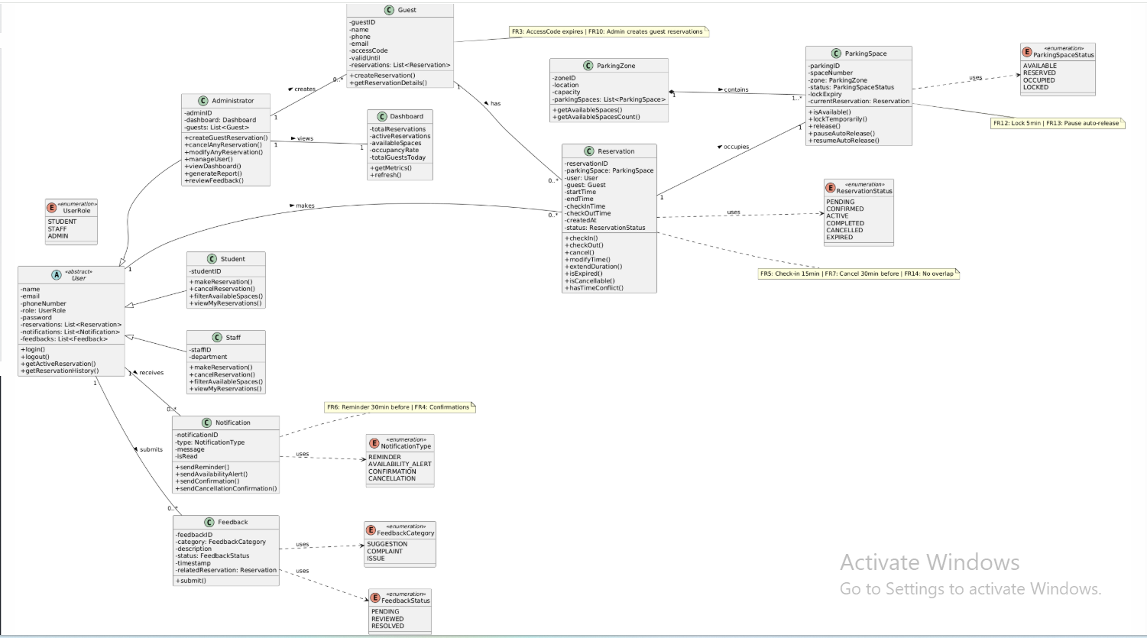

Legend
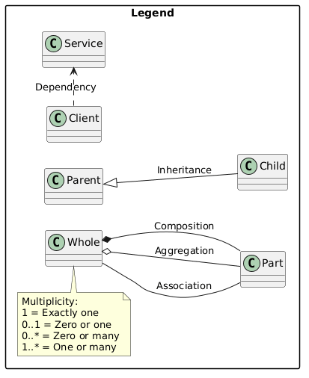

4. Application of SOLID Principles
- SRP states that each class should have a single, well-defined responsibility, therefore, it should only have one reason to change.

Examples of SRP from the class design:
- The User class is only responsible for managing user-related data and authenticating users (e.g. login() and logout()).

- Student and Staff classes handle reservation related actions specific to their roles like makeReservation(), cancelReservation(), and viewAvailableSpaces().
- These classes do not include administrative functionalities like reserving for guests, managing users, and generating reports.
- Their primary reason to change would be changes in the booking process or permissions.

- The Reservation class is another example of SRP. It is responsible for managing the lifecycle of the reservation.
- This class handles lifecycle-related operations such as checkin(), cancel(), modifyTime() and detects reservation time conflicts with hasTimeConflict().
- It’s only reason to change would be modification to reservation lifecycle rules, like checkin() and checkout(), etc.

- Another example is ParkingSpace class. This class only handles the state of every individual parking space.
- It includes operations related only to each parking space such as: isAvailable(), lockTemporarily() (for ongoing booking or modification), and release().
- The only reason for this class to change: modification to the behavior state of individual parking spaces.

- The ParkingZone class is responsible for grouping collections of parking spaces.
- It provides operations such as getAvailableSpaces() and tracking zone information.
- It does not however manage or control individual parking space behaviors as this is the task of the ParkingSpace class.
- The only reason for this class to change: changes in parking zone logic.

- OCP states that a class or module should be open for extension but closed for modification. This means that new functionality can be added without altering existing code, reducing the risk of introducing bugs.
- User Class
Base class: User
Extended by:
- Student
- Staff
- Administrator
  - New roles can be added, such as Visitor or Security, without changing the User class.
  - Each subclass can implement its own behavior or permissions, keeping high-level logic untouched.

- LSP states that subclasses should be able to replace their base class without altering the correctness of the program.

In this design, LSP is applied through the Inheritance relationship between User and its subclasses (Student and Staff).
- Both Student and Staff have common user-related behaviors such as making and cancelling reservations.
- These classes do not override the inherited behaviors in a way that changes their functionality.

Where common behavior exists across subclasses, they maintain consistent behavior without breaking expectations. This ensures that Student and Staff objects can be used interchangeably where shared User behavior is expected.

- ISP states that classes should not be forced to depend on methods they do not use.

In this design, although explicit interfaces are not modeled, responsibilities are separated such that classes only include methods relevant to their role.

- The Reservation class only includes methods related to reservation lifecycle management such as checkIn(), cancel(), and modifyTime(), and does not include unrelated functionality.

- The ParkingZone class also only provides zone-level operations like getAvailableSpaces(), without unnecessary methods related to individual parking space behavior.

5. The DIP states that high-level modules should not depend on low-level modules; both should depend on abstractions.

In this design, DIP can be applied through the relationship between Reservation and Notification.

Reservation acts as a high-level module that triggers actions such as confirmation and reminders, while Notification represents the abstraction for sending those messages.
Instead of depending on a specific implementation of how notifications are delivered, Reservation depends only on the Notification interface-like behavior defined in the diagram.

This ensures that the notification mechanism can vary without affecting the reservation logic. Both modules remain loosely coupled, improving flexibility and maintainability.

5. Design Patterns
- Factory Method (Creational)
Used when creating reservations.
For Example:
Student.makeReservation(), Staff.makeRservation(),
Administrator.createGuestReservation().

Why is it useful:

- Avoids code repetition for creation code.
- Different types of users need different reservation rules (e.g. guests can’t book their own reservations)
- Encapsulates object creation logic
Participating classes:
Creator: User
Concrete creators: Staff, Student, Administrator
Product: Reservation

2. Observer Pattern (Behavioral)
Where it’s used:
Notification system:
Examples:
  - Reminder notifications (before reservation time)
  - Confirmation notifications
  - Cancellation notifications

Why is it useful:
- Allows the system to automatically notify users when changes occur (e.g., reservation updates).
- Decouples notification logic from core system logic like reservations.
- Improves scalability for adding more notification types.

Participating classes:
Subject (implicit): Reservation
Observer: Notification
Receiver: User

3. Facade Pattern (Structural)
Where it’s used:
Dashboard class acts as a facade.

Why is it useful:
- aggregates information such as total reservations, active reservations, available spaces, occupancy rate. So instead of accessing multiple classes the system uses DashBoard to get summarized data.

Participating classes:
Facade: Dashboard
Subsystem Classes: Reservation, ParkingZone, ParkingSpace

6. Data Design

6.1 Main Entities
The UDST Smart Parking Management System stores data persistently across 9 entities. Below is a description of each:
- User: stores the shared information of all system users including their name, email, phone number, password, and role.
- Student: extends User with a university student ID.
- Staff: extends User with a university staff ID and department.
- Administrator: extends User with an admin ID granting elevated system privileges.
- ParkingZone: represents a designated parking area on campus with a location and total capacity.
- ParkingSpace: represents an individual parking spot within a zone, tracking its current status and temporary lock expiry.
- Reservation: the core entity of the system, storing all booking details including time slot, check-in/out times, status, and guest information.
- Notification: stores reminders and confirmation messages sent to users.
- Feedback: stores complaints, reports, and feedback submitted by users linked to their reservation.

6.2 Key Data Structures
Entity | Key Fields
User | userID (PK), name, email, phoneNumber, password, role
Student | studentID (PK), userID (FK)
Staff | staffID (PK), department, userID (FK)
Administrator | adminID (PK), userID (FK)
ParkingZone | zoneID (PK), location, capacity
ParkingSpace | parkingID (PK), spaceNumber, zoneID (FK), status, lockExpiry
Reservation | reservationID (PK), userID (FK), spaceID (FK), guestName, startTime, endTime, checkInTime, checkOutTime, createdAt, status
Notification | notificationID (PK), userID (FK), type, message, isRead
Feedback | feedbackID (PK), userID (FK),  reservationID (FK), category, description, status, timestamp

6.3 Entity Relationship Diagram
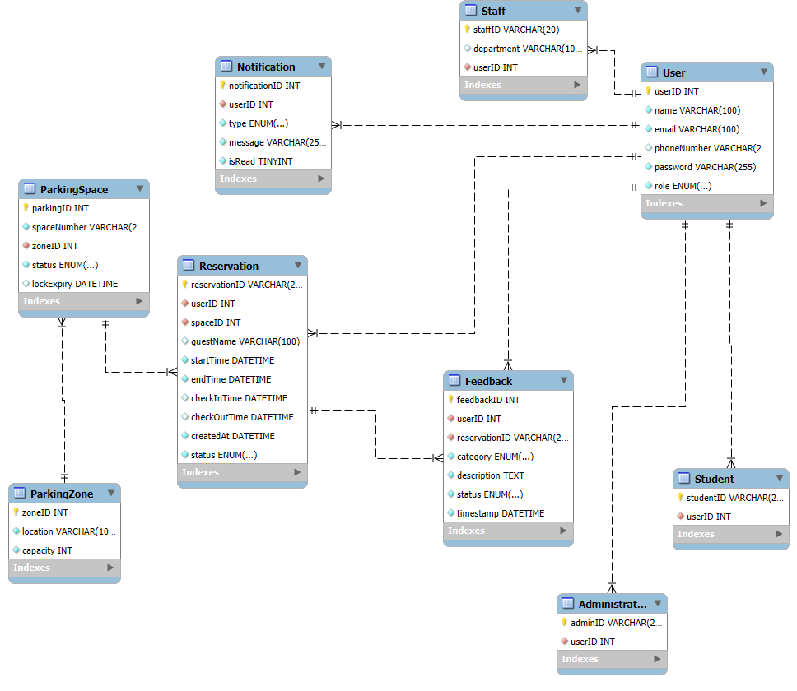

7. Traceability Matrix
Design_traceability_table.xlsx

